Application required to run Hollywood project

1. Node v20.12.2
2. JDK 17
3. Apache Maven 3.8.8
4. MySQL Server 8.2

Run Hollywood api application

1. step 1: cd hollywood.api
2. step 2: change application.properties (in src/main/resources)if you are using different port,username,password
3. // here my mysql running on port 3307
4. spring.datasource.url=jdbc:mysql://localhost:3307/hollywood?zeroDateTimeBehavior=convertToNull&useSSL=false&useLegacyDatetimeCode=false&serverTimezone=UTC&enableQueryTimeouts=false&autoReconnet=true&useUnicode=true&characterEncoding=utf8
5. spring.datasource.username=root
6. spring.datasource.password=root123
7. check swagger documentation http://localhost:8081/swagger-ui/index.html#/

step 2: mvn clean install && java -jar target/hollywood.api-0.0.1-SNAPSHOT.jar --debug (build and run application and ensure port 8081 should be free)

Import holliwood database

1. step 1:- Execute command after placing hollywood_structure.sql to your current directory
2. mysql --host="localhost" --user=root --password=root123 --port=3307 < hollywood_structure.sql
3. or Execute the sql code (which is inside hollywood_structure.sql ) to IDE ex mysql workbench

Run Ui Hollywood (Angular 17) application

1. **step 1:** cd Hollywood
2. **step 2:** npm install
3. **step 3:** ng serve -o

**Demo pics :-**

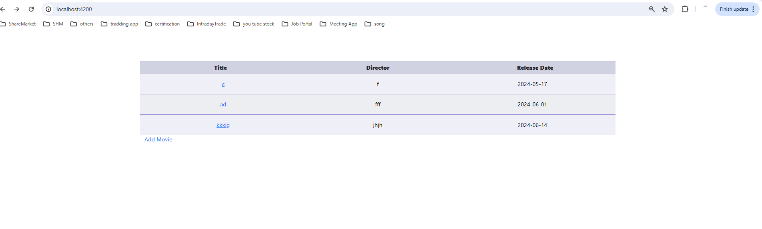

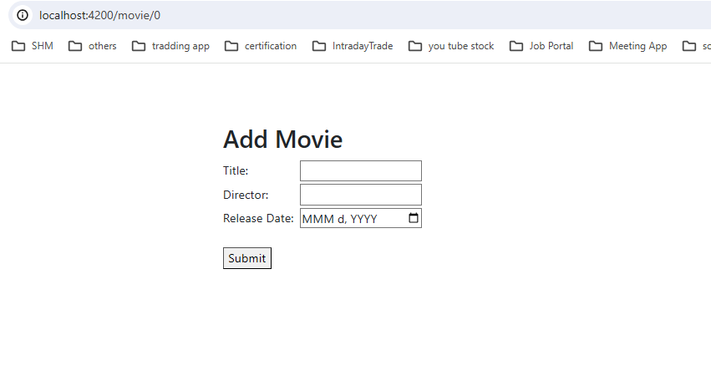

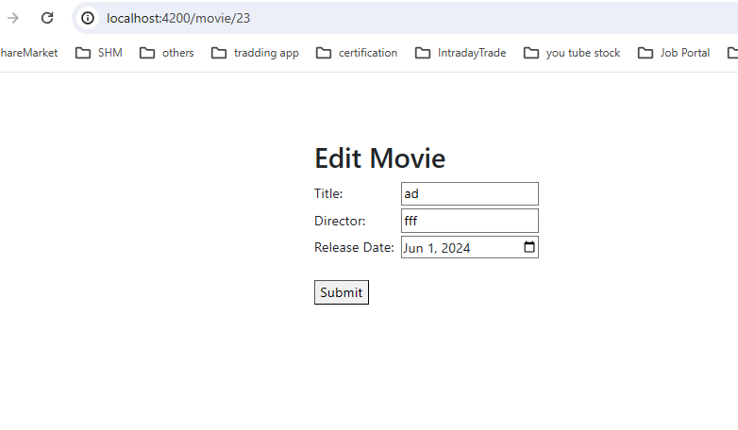

**SWAGGER UI**

